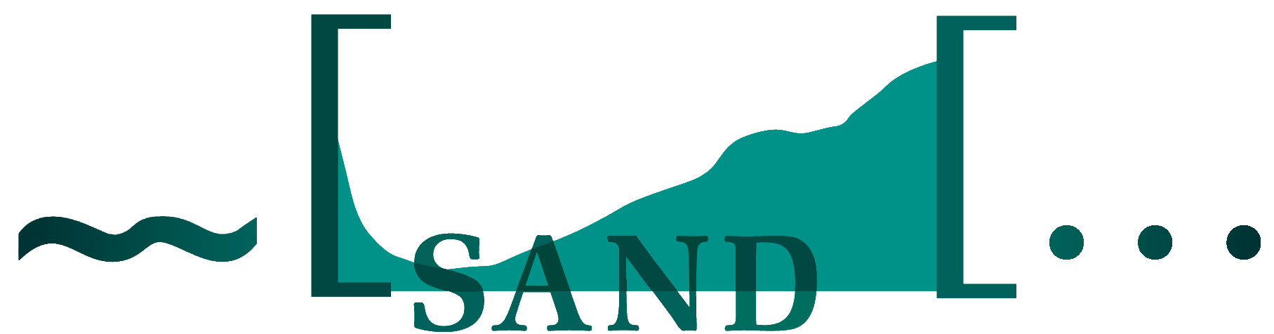

DynaSAND

An on-line corpus of elicited speech and text for dialect syntactic research

Sjef Barbiers & Jan Pieter Kunst
Meertens Institute
DynaSAND
http://www/meertens.nl/sand/

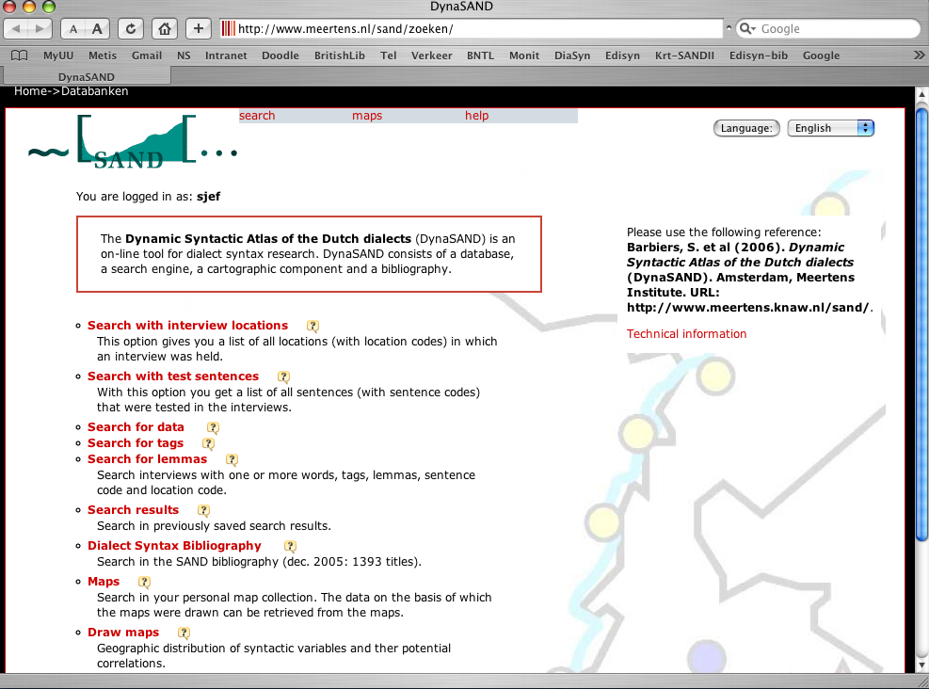

DynaSAND contains (1):

(i) SAND-bibliography (1300 titles)

(ii) Written questionnaire (2000)
- 368 informants
- 321 locations (Netherlands and Belgium)
- 424 test sentences
- Elicitation tasks: translation, (relative) grammaticality judgements, meaning judgements, cloze tests

DynaSAND contains (2):

(iii) Oral questionnaire (2001-2002):
- 267 interviews (on average,1 hour and 45 minutes)
- 267 locations (Netherlands, Belgium and France)
- More than 530 informants (min. 2 in each location) ;
- 160 test sentences (on average)
- Tasks: translation, (relative) grammaticality judgements, cloze tests, picture tasks
- Question – answer pairs accessible as (partly tagged ) transcriptions linked with sound files
- For each location: 10 minutes of spontaneous dialect conversation (to be transcribed)
DynaSAND contains (3):

(iv) Telephone interviews (2003):
- 252 interviews
- 252 locations in The
Netherlands and Belgium
- 100 test sentences (on average)

Total:
515 MB
447 hours of speech
1.222.000 words
DynaSAND Search engine

Searches with
- Locations
- Test sentences
- Key words
- Strings (incl. words,
wildcards, lemma’s)
- Tags
Output (i)

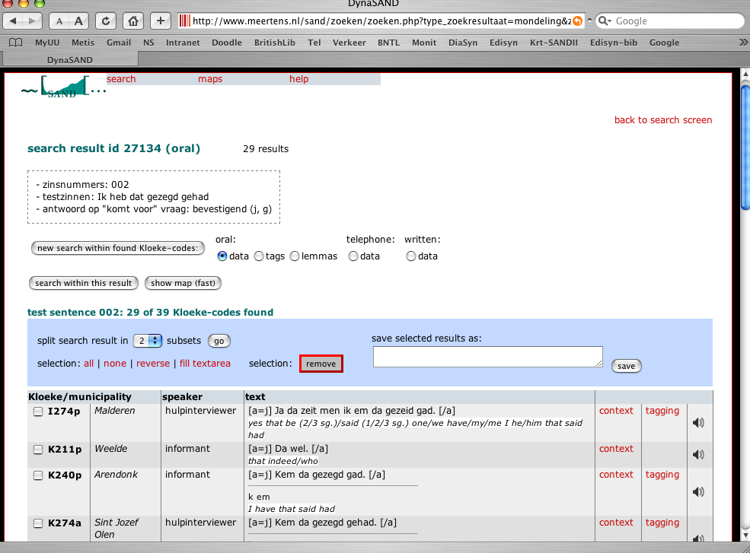

Output (ii)

